Morning Prayer Rite Two
Sundays in Lent

Opening Sentence and Confession

Opening Sentence
The Officiant says
If we say we have no sin, we deceive ourselves, and the truth is not in us, but if we confess our sins, God, who is faithful and just, will forgive our sins and cleanse us from all unrighteousness. 1 John 1:8, 9

Confession of Sin
The Officiant says to the people
Dearly beloved, we have come together in the presence of Almighty God our heavenly Father, to set forth his praise, to hear his holy Word, and to ask, for ourselves and on behalf of others, those things that are necessary for our life and our salvation. And so that we may prepare ourselves in heart and mind to worship him, let us kneel in silence, and with penitent and obedient hearts confess our sins, that we may obtain forgiveness by his infinite goodness and mercy.
Silence may be kept.
Officiant and People together, all kneeling
Most merciful God,
we confess that we have sinned against you
in thought, word, and deed,
by what we have done,
and by what we have left undone.
We have not loved you with our whole heart;
we have not loved our neighbors as ourselves.
We are truly sorry and we humbly repent.
For the sake of your Son Jesus Christ,
have mercy on us and forgive us;
that we may delight in your will,
and walk in your ways,
to the glory of your Name. Amen.
The Priest alone stands and says
Almighty God have mercy on us, forgive us all our sins through our Lord Jesus Christ, strengthen us in all goodness, and by the power of the Holy Spirit keep us in eternal life. Amen.

The Invitatory and Psalter

Invitatory
All stand
Officiant | Lord, open our lips.
People | And our mouth shall proclaim your praise.

Officiant and People
Glory to the Father, and to the Son, and to the Holy Spirit: as it was in the beginning, is now, and will be for ever. Amen.
The Lord is full of compassion and mercy: Come let us adore him.

Venite Psalm 95:1-7
Come, let us sing to the Lord; *
let us shout for joy to the Rock of our salvation.
Let us come before his presence with thanksgiving *
and raise a loud shout to him with psalms.
For the Lord is a great God, *
and a great King above all gods.
In his hand are the caverns of the earth, *
and the heights of the hills are his also.
The sea is his, for he made it, *
and his hands have molded the dry land.
Come, let us bow down, and bend the knee, *
and kneel before the Lord our Maker.
For he is our God,
and we are the people of his pasture and the sheep of his hand. *
Oh, that today you would hearken to his voice!

The psalm as Appointed (see supplement)

At the end of the Psalm is sung or said

Glory to the Father, and to the Son, and to the Holy Spirit:*
as it was in the beginning, is now, and will be for ever. Amen.

CANTICLE HYMN

The Lessons

One or two Lessons, as appointed, are read, the Reader first saying

A Reading (Lesson) from________________

A citation giving chapter and verse may be added.

After each Lesson the Reader may say

The Word of the Lord.
Answer Thanks be to God.

Or the Reader may say Here ends the Lesson (Reading).

Silence may be kept after each Reading. One of the following Canticles, or one of those
on pages 47-52 (Canticles 1-7), is sung or said after each Reading. If three Lessons
are used, the Lesson from the Gospel is read after the second Canticle.

First Canticle
Canticle 14: A Song of Penitence
Kyrie Pantokrator
Prayer of Manasseh 1-2, 4, 6-7, 11-15
O Lord and Ruler of the hosts of heaven, *
God of Abraham, Isaac, and Jacob,
and of all their righteous offspring:
You made the heavens and the earth, *
with all their vast array.
All things quake with fear at your presence; *
they tremble because of your power.
But your merciful promise is beyond all measure; *
it surpasses all that our minds can fathom.
O Lord, you are full of compassion, *
long-suffering, and abounding in mercy.
You hold back your hand; *
you do not punish as we deserve.
In your great goodness, Lord,
you have promised forgiveness to sinners, *
that they may repent of their sin and be saved.
And now, O Lord, I bend the knee of my heart, *
and make my appeal, sure of your gracious goodness.
I have sinned, O Lord, I have sinned, *
and I know my wickedness only too well.
Therefore I make this prayer to you: *
Forgive me, Lord, forgive me.
Do not let me perish in my sin, *
nor condemn me to the depths of the earth.
For you, O Lord, are the God of those who repent, *
and in me you will show forth your goodness.
Unworthy as I am, you will save me,
in accordance with your great mercy, *
and I will praise you without ceasing all the days of my life.
For all the powers of heaven sing your praises, *
and yours is the glory to ages of ages. Amen.

SECOND READING

A Reading (Lesson) from________________

A citation giving chapter and verse may be added.

After each Lesson the Reader may say

The Word of the Lord.
Answer Thanks be to God.

Or the Reader may say Here ends the Lesson (Reading).

GRADUAL HYMN

GOSPEL READING

The Holy Gospel of our Lord Jesus Christ
according to__________________.
People Glory to you, Lord Christ.
After the Gospel, the Reader says

The Gospel of the Lord.
People Praise to you, Lord Christ.

THE SERMON

The Apostles’ Creed
Officiant and People together, all standing.
I believe in God, the Father almighty,
creator of heaven and earth.
I believe in Jesus Christ, God’s only Son, our Lord,
who was conceived by the Holy Spirit,
born of the Virgin Mary,
suffered under Pontius Pilate,
was crucified, died, and was buried;
he descended to the dead.
On the third day he rose again;
he ascended into heaven,
he is seated at the right hand of the Father,
and he will come again to judge the living and the dead.
I believe in the Holy Spirit,
the holy catholic Church,
the communion of saints,
the forgiveness of sins,
the resurrection of the body,
and the life everlasting. Amen.

OFFICE HYMN

The Prayers

Salutation
The people stand or kneel
Officiant | The Lord be with you.
People | And also with you.
Officiant | Let us pray.

The Lord’s Prayer
Officiant and People
Our Father in heaven,
hallowed be your Name,
your kingdom come,
your will be done, on earth as in heaven.
Give us today our daily bread.
Forgive us our sins
as we forgive those who sin against us.
Save us from the time of trial
and deliver us from evil.
For the kingdom, the power,
and the glory are yours,
now and forever. Amen.

Suffrages
V. Show us your mercy, O Lord;
R. And grant us your salvation.
V. Clothe your ministers with righteousness;
R. Let your people sing with joy.
V. Give peace, O Lord, in all the world;
R. For only in you can we live in safety.
V. Lord, keep this nation under your care;
R. And guide us in the way of justice and truth.
V. Let your way be known upon earth;
R. Your saving health among all nations.
V. Let not the needy, O Lord, be forgotten;
R. Nor the hope of the poor be taken away.
V. Create in us clean hearts, O God;
R. And sustain us with your Holy Spirit.
The Officiant then says one or more of the following Collects

The Collect of the Day
COLLECT FOR SUNDAYS

O God, you make us glad with the weekly remembrance of the glorious resurrection of your Son our Lord: Give us this day such blessing through our worship of you, that the week to come may be spent in your favor; through Jesus Christ our Lord. Amen.

Second Collect
Almighty God, who after the creation of the world rested from all your works and sanctified a day of rest for all your creatures: Grant that we, putting away all earthly anxieties, may be duly prepared for the service of your sanctuary, and that our rest here upon earth may be a preparation for the eternal rest promised to your people in heaven; through Jesus Christ our Lord. Amen.

Prayer For Mission
O God, you have made of one blood all the peoples of the earth, and sent your blessed Son to preach peace to those who are far off and to those who are near: Grant that people everywhere may seek after you and find you; bring the nations into your fold; pour out your Spirit upon all flesh; and hasten the coming of your kingdom; through Jesus Christ our Lord. Amen.

Intercessions and thanksgivings may be offered here.

A Prayer of St. Chrysostom
Officiant and People
Almighty God, you have given us grace at this time with one accord to make our common supplication to you; and you have promised through your well-beloved Son that when two or three are gathered together in his Name you will be in the midst of them: Fulfill now, O Lord, our desires and petitions as may be best for us; granting us in this world knowledge of your truth, and in the age to come life everlasting. Amen.

CLOSING HYMN

Concluding Versicle
Let us bless the Lord.
Thanks be to God.

Concluding Sentence
The grace of our Lord Jesus Christ, and the love of God, and the fellowship of the Holy Spirit, be with us all evermore. Amen. 2 Corinthians 13:14

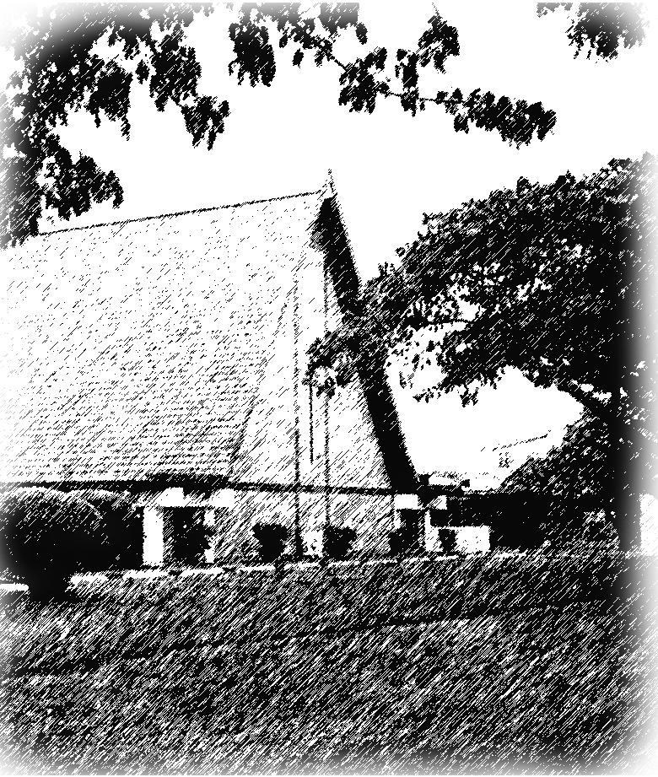

ST. TIMOTHY’S EPISCOPAL CHURCH
98-939 Moanalua Road | ‘Aiea, HI 96701| (808)488-5747
Office@sttimothysaiea.org | www.sttimothysaiea.org
St. Timothy’s Episcopal Church, Aiea Sttimothysaiea @sttimothysaiea

The Right Reverend Robert L. Fitzpatrick, V Bishop of Hawai‘i
The Rev. Daniel L. Leatherman, Priest in Charge
Angie Delight, Musican

Copyright © 2020 Church Publishing Inc. All rights reserved. Used with permission.

